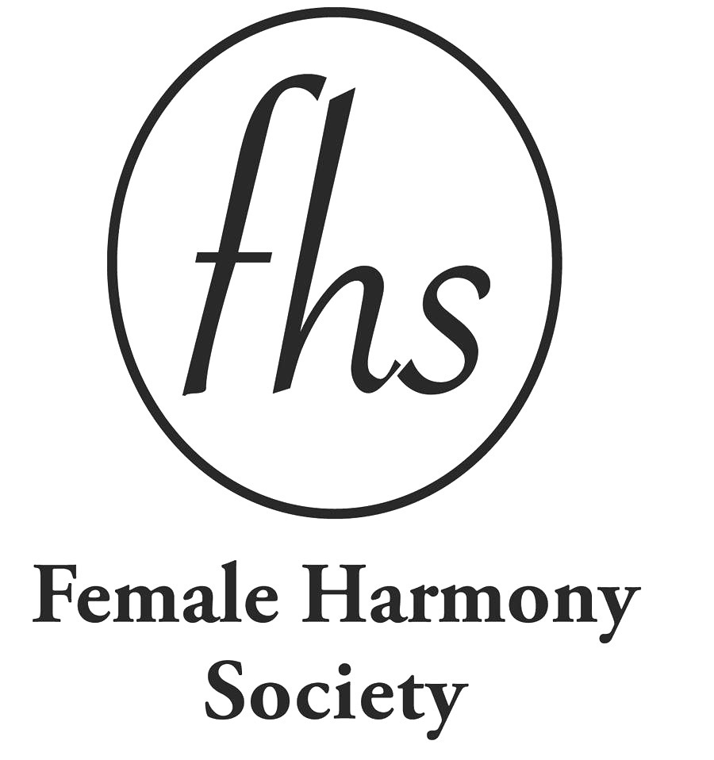

MARYBELL ENSLEN MEMORIAL SCHOLARSHIP

For the 2023-24 Academic Year

The application is posted at www.femaleharmonysociety.org

To be considered, the completed application form and the following supporting materials must be postmarked or e-mailed on or before December 30, 2023 and include:

1. An official sealed transcript(s) from the college you are currently attending. If this is your first semester at this school, send a transcript from the school you last attended.
2. The essay as described below.

RETURN APPLICATION AND SUPPORTING PAPERS TO:

Female Harmony Society, c/o Maggie Alexander, 2409 Brickton Rd. , Wilmington, DE 19803

Or

E-mail to: Maggie Alexander - Maggiea10@verizon.net

(Confidential Information - Please print or type)

Date:_________________ Birth Date:________________

Name:__________________________________________________________
(Last) (First) (Middle)

Home Address:_____________________________________________________________________

(Street) (City) (State) (Zip)

Phone: Home ________________Cell_________________

Email___________________________

1. What is your relationship to Hanover? ____________________________________________
______________________________________________________________________________

2. What schools have you attended?

College Years Attended Major Degree or credits

________________________________________________________________________________

Graduate School Years Attended Major Degree or credits

____________________________________________________________________________________

3. What is your GPA at the college you are currently attending? ________________

Essay: Please type, and complete on a separate sheet of paper.

In 150 to 200 words, state what you plan to study, what your career goals are, and how you will help others through your chosen field.

SIGNATURE

Your Signature : _____________________________DATE:_______________

All applications and supporting documents are treated with confidentiality and are shredded at theconclusion of the selection process.

Essay:

I have the privilege of teaching Pre Kindergarten aged children. My class is made up of students with disabilities and typically developing children. I have been teaching in person, but now will be returning to remote learning with my students due to the uptick in COVID-19 cases in Delaware. I completed my Bachelors and Masters degrees in Early Childhood related majors at the University of Delaware, with help from this scholarship fund. My passion for higher education didn’t cease there, and I had been looking into furthering my education for a while. It wasn’t until I saw the profound need for social interaction and the lack of social and emotional skills my students had during virtual learning, that I thought I should improve my practices with teaching it. I began searching for programs focused on social and emotional learning, figuring I wouldn’t find many, and was excited to see one was housed at Neumann University! Since starting the program, the classes have been online (due to COVID-19), but still remain interactive as they are live on Sunday afternoons. I have learned so much about identifying and addressing social and emotional needs since starting this program. An added bonus has been sharing resources with my classmates and professors who are on the unique remote learning journey as well. After completing this program, I plan to continue my position as a special education teacher, with the added implementation of skills learned about social and emotional development, which is critical for all learners, but especially the youngest ones.

